**Installation**

**Prerequsites**

1. Install serverless globally
   1. **npm i -g serverless**
2. Install python packages
   1. **pip install -r requirements.txt**
3. Do npm install which install all the required pacakges
   1. **npm i**
4. Create s3 bucket with name **bedrock-python-code.**
5. Serverless deploy once everything is installed
   1. **serverless deploy**

**Cloud Steps**

1. **Navigate to IAM. There will be role created** [**bedrock-api-v1-dev-us-east-1-lambdaRole**](https://us-east-1.console.aws.amazon.com/iam/home?region=us-east-1#/roles/details/bedrock-api-v1-dev-us-east-1-lambdaRole)**. In that add permissions.**

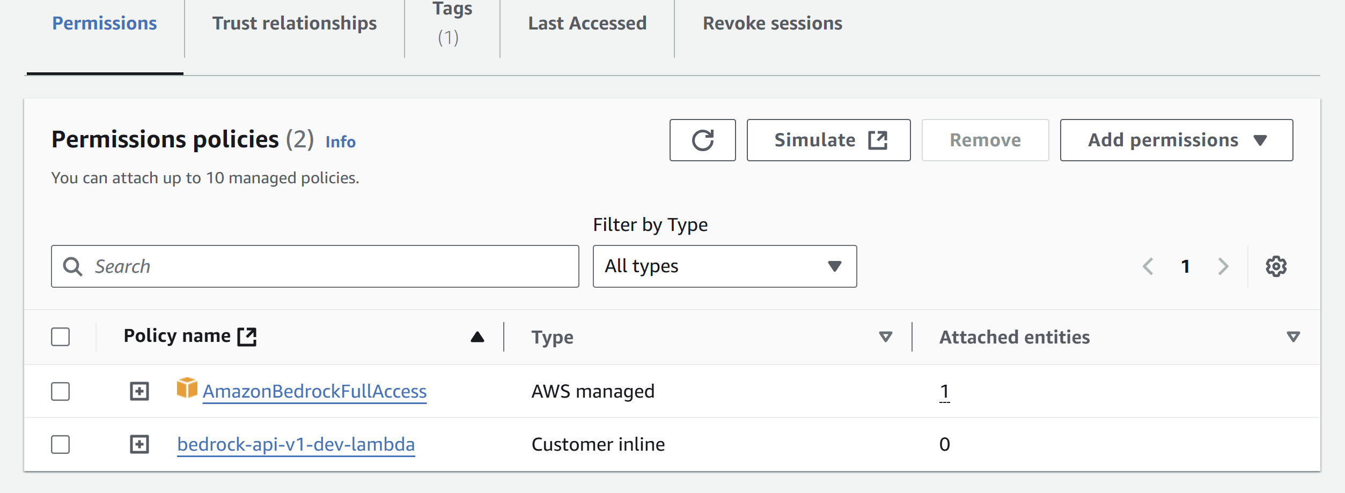

1. **Navigate to s3. Copy the below policy and add to the bucket. In the place of highlighted add the arn created from the role which is pointed in the screenshot below.**{

"Version": "2012-10-17",

"Statement": [

{

"Effect": "Allow",

"Principal": {

"AWS": "arn:aws:iam::590184146847:role/bedrock-api-v1-dev-us-east-1-lambdaRole"

},

"Action": "s3:GetObject",

"Resource": "arn:aws:s3:::bedrock-python-code/*"

}

]

}  
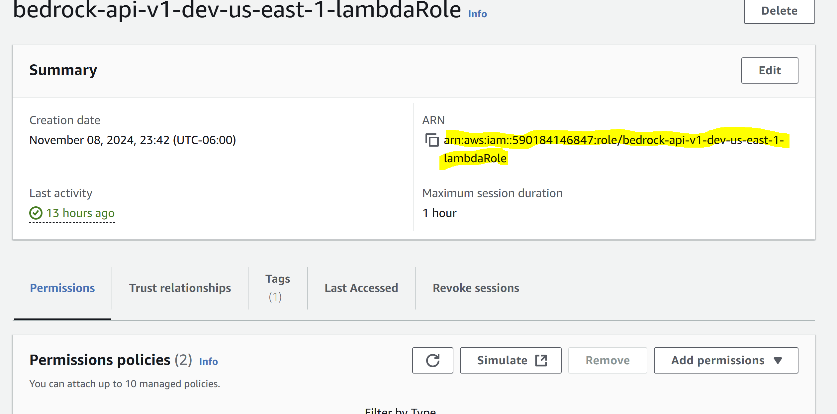

**Testing Code**

**POST** [**http://localhost:5000/query**](http://localhost:5000/query)

**BODY**{

    "prompt": "Who is the borrower, administrative agent in the credit agreement"

}

**RESPONSE**{

    "generated_text": "The borrower in the credit agreement is TestCompany Partners Resources, LLC. The administrative agent in the credit agreement is TestBank1 Bank, N.A.",

    "page_numbers": [],

    "prompt": "Who is the borrower, administrative agent in the credit agreement"

}  
  
**CURL**

curl --location 'http://localhost:5000/query' \

--header 'Content-Type: application/json' \

--data '{

    "prompt": "Who is the borrower, administrative agent in the credit agreement"

}'